Documentație Tree Visualization

Universitatea de Vest din Timișoara
Informatică română, anul II
Didiță Delia Andreea

Descriere

Tree Visualization este un program pentru vizualizarea arborilor (Red-Black Tree, B-Tree, Max Heap Tree). Pentru realizarea acestuia s-a folosit limbajul de programare Python. Pentru interfață s-a folosit PySimpleGUI. Programul folosit a fost PyCharm.

Cum se utilizează
Programul dispune de o interfață simplă, cu 3 tab-uri: Red-Black Tree, B-Tree și Max Heap Tree.

Butoanele:
-„Insert” inserează un nod nou în arbore
-„Delete” șterge un nod din arbore
-„Find” caută un nod după cheie
-„Show Max Value” afișează valoarea maximă din arbore
-„Print” afișează structura arborelui
-„Clear” șterge output-ul afișat
-„Exit” închide programul

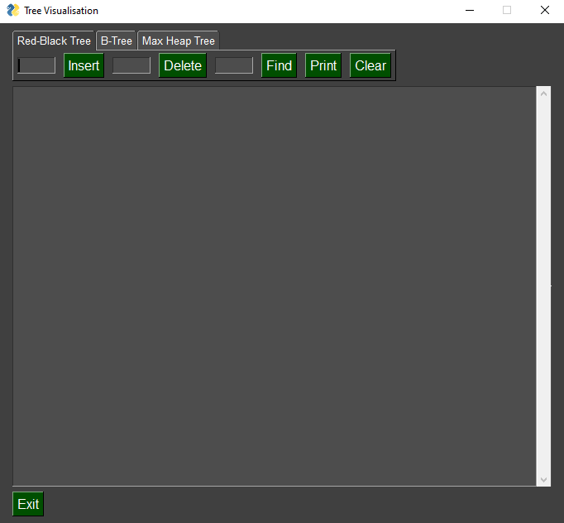

Red-Black Tree

Inserarea nodurilor 1, 2, 3, 4, 5, 6, 7, 8, 9 și afișarea arborelui

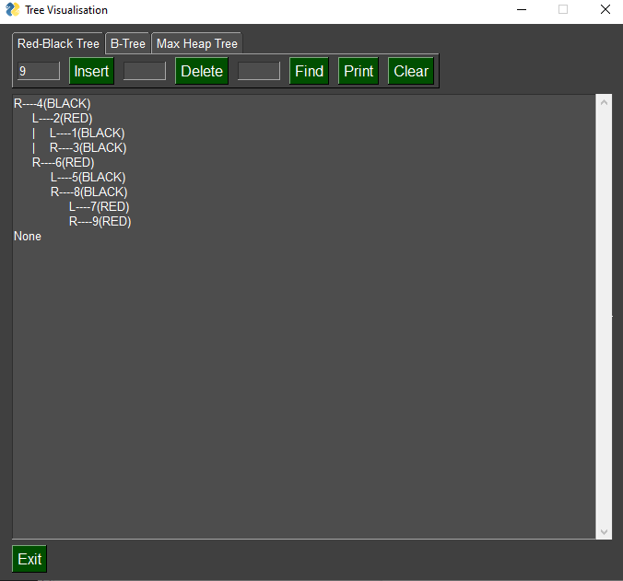

Ștergerea nodului 5 și afișarea arborelui

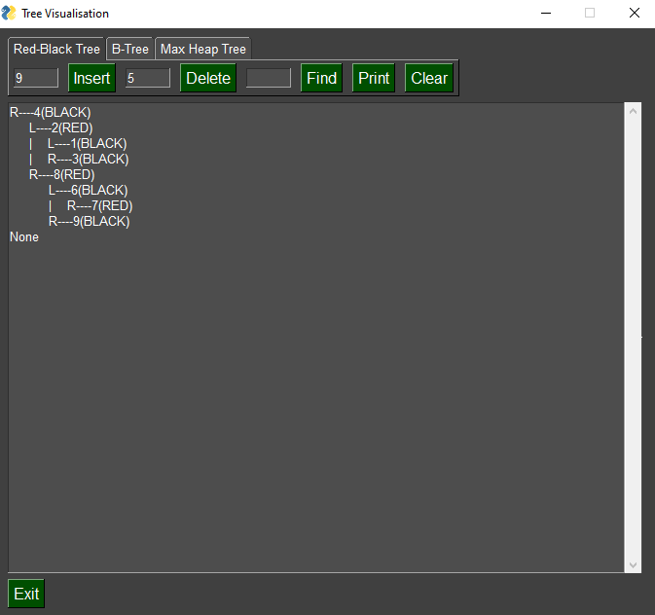

Găsirea unui nod cu o cheie existentă: 3

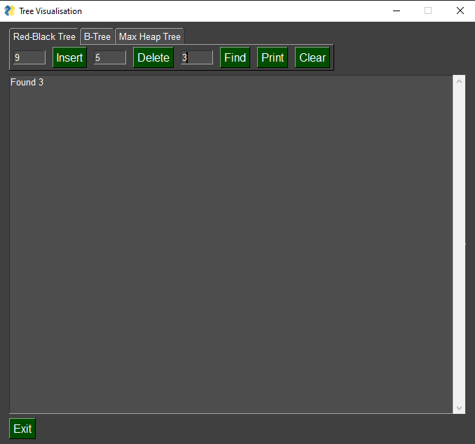

Găsire unui nod cu o cheie inexistentă: 10

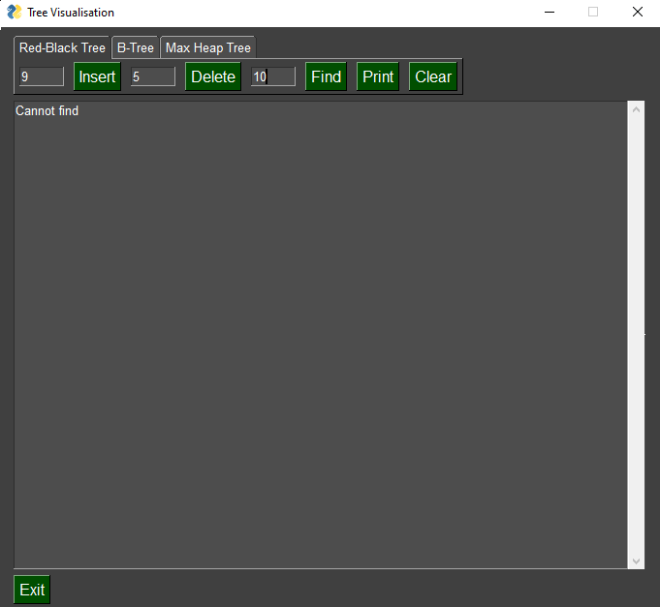

B-Tree

Inserarea nodurilor 1, 2, 3, 4, 5, 6, 7, 8, 9 și afișarea arborelui

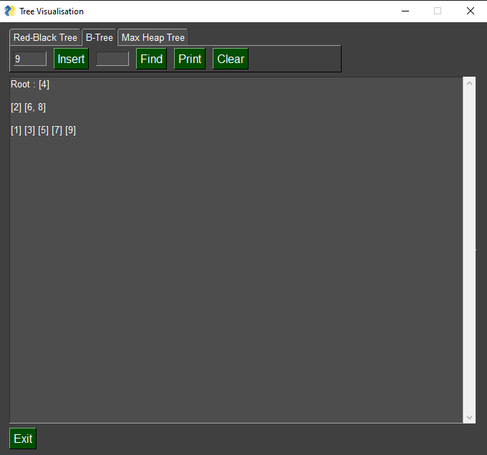

Găsirea unui nod cu o cheie existentă: 8

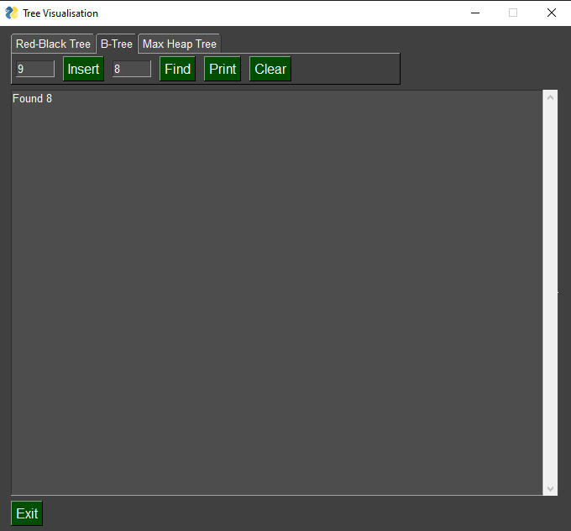

Găsirea unui nod cu o cheie inexistentă: 10

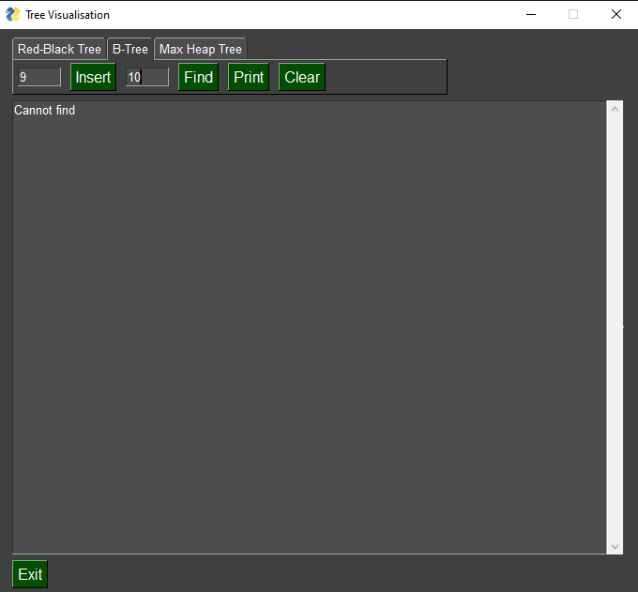

Max Heap Tree

Inserarea nodurilor 1, 2, 3, 4, 5, 6, 7, 8, 9 și afișarea arborelui

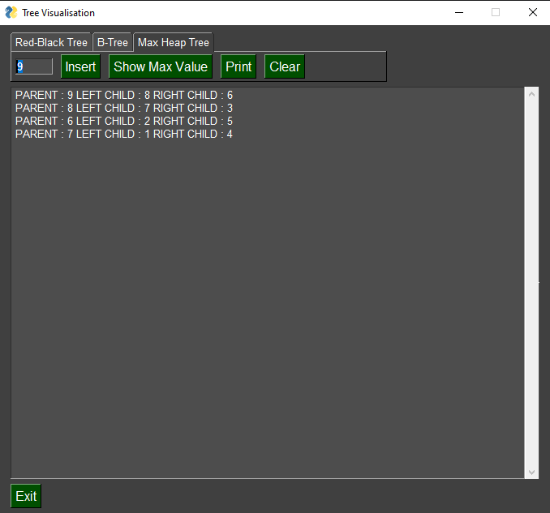

Afișarea nodului cu cheie maximă

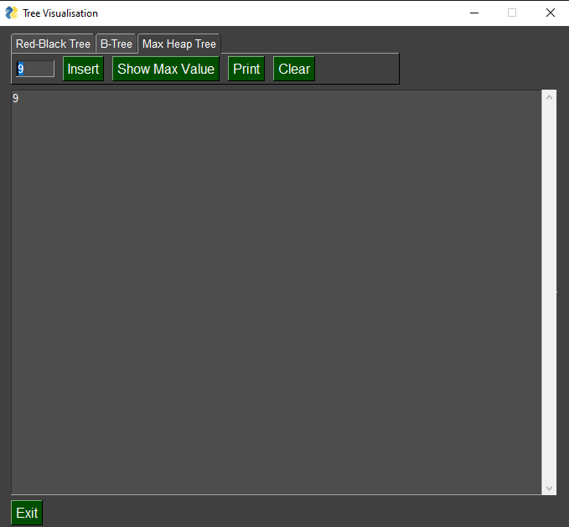

Implementarea

Red-Black Tree

class Node():
def __init__(self, item):
self.item = item
self.parent = None
self.left = None
self.right = None
self.color = 1

class RedBlackTree():
def __init__(self):
self.TNULL = Node(0)
self.TNULL.color = 0
self.TNULL.left = None
self.TNULL.right = None
self.root = self.TNULL

# Preorder
def pre_order_helper(self, node):
if node != TNULL:
sys.stdout.write(node.item + " ")
self.pre_order_helper(node.left)
self.pre_order_helper(node.right)

# Inorder
def in_order_helper(self, node):
if node != TNULL:
self.in_order_helper(node.left)
sys.stdout.write(node.item + " ")
self.in_order_helper(node.right)

# Postorder
def post_order_helper(self, node):
if node != TNULL:
self.post_order_helper(node.left)
self.post_order_helper(node.right)
sys.stdout.write(node.item + " ")

# Search the tree
def search_tree_helper(self, node, key):
if node == TNULL or key == node.item:
return node

if key < node.item:
return self.search_tree_helper(node.left, key)
return self.search_tree_helper(node.right, key)

# Balancing the tree after deletion
def delete_fix(self, x):
while x != self.root and x.color == 0:
if x == x.parent.left:
s = x.parent.right
if s.color == 1:
s.color = 0
x.parent.color = 1
self.left_rotate(x.parent)
s = x.parent.right

if s.left.color == 0 and s.right.color == 0:
s.color = 1
x = x.parent
else:
if s.right.color == 0:
s.left.color = 0
s.color = 1
self.right_rotate(s)
s = x.parent.right

s.color = x.parent.color
x.parent.color = 0
s.right.color = 0
self.left_rotate(x.parent)
x = self.root
else:
s = x.parent.left
if s.color == 1:
s.color = 0
x.parent.color = 1
self.right_rotate(x.parent)
s = x.parent.left

if s.right.color == 0 and s.right.color == 0:
s.color = 1
x = x.parent
else:
if s.left.color == 0:
s.right.color = 0
s.color = 1
self.left_rotate(s)
s = x.parent.left

s.color = x.parent.color
x.parent.color = 0
s.left.color = 0
self.right_rotate(x.parent)
x = self.root
x.color = 0

def __rb_transplant(self, u, v):
if u.parent == None:
self.root = v
elif u == u.parent.left:
u.parent.left = v
else:
u.parent.right = v
v.parent = u.parent

# Node deletion
def delete_node_helper(self, node, key):
z = self.TNULL
while node != self.TNULL:
if node.item == key:
z = node

if node.item <= key:
node = node.right
else:
node = node.left

if z == self.TNULL:
print("Cannot find key in the tree")
return

y = z
y_original_color = y.color
if z.left == self.TNULL:
x = z.right
self.__rb_transplant(z, z.right)
elif (z.right == self.TNULL):
x = z.left
self.__rb_transplant(z, z.left)
else:
y = self.minimum(z.right)
y_original_color = y.color
x = y.right
if y.parent == z:
x.parent = y
else:
self.__rb_transplant(y, y.right)
y.right = z.right
y.right.parent = y

self.__rb_transplant(z, y)
y.left = z.left
y.left.parent = y
y.color = z.color
if y_original_color == 0:
self.delete_fix(x)

# Balance the tree after insertion
def fix_insert(self, k):
while k.parent.color == 1:
if k.parent == k.parent.parent.right:
u = k.parent.parent.left
if u.color == 1:
u.color = 0
k.parent.color = 0
k.parent.parent.color = 1
k = k.parent.parent
else:
if k == k.parent.left:
k = k.parent
self.right_rotate(k)
k.parent.color = 0
k.parent.parent.color = 1
self.left_rotate(k.parent.parent)
else:
u = k.parent.parent.right

if u.color == 1:
u.color = 0
k.parent.color = 0
k.parent.parent.color = 1
k = k.parent.parent
else:
if k == k.parent.right:
k = k.parent
self.left_rotate(k)
k.parent.color = 0
k.parent.parent.color = 1
self.right_rotate(k.parent.parent)
if k == self.root:
break
self.root.color = 0

# Printing the tree
def __print_helper(self, node, indent, last):
if node != self.TNULL:
sys.stdout.write(indent)
if last:
sys.stdout.write("R----")
indent += " "
else:
sys.stdout.write("L----")
indent += "| "

s_color = "RED" if node.color == 1 else "BLACK"
print(str(node.item) + "(" + s_color + ")")
self.__print_helper(node.left, indent, False)
self.__print_helper(node.right, indent, True)

def preorder(self):
self.pre_order_helper(self.root)

def inorder(self):
self.in_order_helper(self.root)

def postorder(self):
self.post_order_helper(self.root)

def searchTree(self, k):
return self.search_tree_helper(self.root, k)

def minimum(self, node):
while node.left != self.TNULL:
node = node.left
return node

def maximum(self, node):
while node.right != self.TNULL:
node = node.right
return node

def successor(self, x):
if x.right != self.TNULL:
return self.minimum(x.right)

y = x.parent
while y != self.TNULL and x == y.right:
x = y
y = y.parent
return y

def predecessor(self, x):
if (x.left != self.TNULL):
return self.maximum(x.left)

y = x.parent
while y != self.TNULL and x == y.left:
x = y
y = y.parent

return y

def left_rotate(self, x):
y = x.right
x.right = y.left
if y.left != self.TNULL:
y.left.parent = x

y.parent = x.parent
if x.parent == None:
self.root = y
elif x == x.parent.left:
x.parent.left = y
else:
x.parent.right = y
y.left = x
x.parent = y

def right_rotate(self, x):
y = x.left
x.left = y.right
if y.right != self.TNULL:
y.right.parent = x

y.parent = x.parent
if x.parent == None:
self.root = y
elif x == x.parent.right:
x.parent.right = y
else:
x.parent.left = y
y.right = x
x.parent = y

def insert(self, key):
node = Node(key)
node.parent = None
node.item = key
node.left = self.TNULL
node.right = self.TNULL
node.color = 1

y = None
x = self.root

while x != self.TNULL:
y = x
if node.item < x.item:
x = x.left
else:
x = x.right

node.parent = y
if y == None:
self.root = node
elif node.item < y.item:
y.left = node
else:
y.right = node

if node.parent == None:
node.color = 0
return

if node.parent.parent == None:
return

self.fix_insert(node)

def get_root(self):
return self.root

def delete_node(self, item):
self.delete_node_helper(self.root, item)

def print_tree(self):
self.__print_helper(self.root, "", True)

def find(self, node, key):
ok=0
while node != self.TNULL:
if node.item == key:
print('Found', key)
ok=1

if node.item <= key:
node = node.right
else:
node = node.left
if ok == 0:
print("Cannot find")

B-Tree

class Node:
def __init__(self, data, par=None):
# print ("Node __init__: " + str(data))
self.data = list([data])
self.parent = par
self.child = list()

def __str__(self):
if self.parent:
return str(self.parent.data) + ' : ' + str(self.data)
return 'Root : ' + str(self.data)

def __lt__(self, node):
return self.data[0] < node.data[0]

def _isLeaf(self):
return len(self.child) == 0

# merge new_node sub-tree into self node
def _add(self, new_node):
# print ("Node _add: " + str(new_node.data) + ' to ' + str(self.data))
for child in new_node.child:
child.parent = self
self.data.extend(new_node.data)
self.data.sort()
self.child.extend(new_node.child)
if len(self.child) > 1:
self.child.sort()
if len(self.data) > 2:
self._split()

# find correct node to insert new node into tree
def _insert(self, new_node):
# print ('Node _insert: ' + str(new_node.data) + ' into ' + str(self.data))

# leaf node - add data to leaf and rebalance tree
if self._isLeaf():
self._add(new_node)

# not leaf - find correct child to descend, and do recursive insert
elif new_node.data[0] > self.data[-1]:
self.child[-1]._insert(new_node)
else:
for i in range(0, len(self.data)):
if new_node.data[0] < self.data[i]:
self.child[i]._insert(new_node)
break

# 3 items in node, split into new sub-tree and add to parent
def _split(self):
# print("Node _split: " + str(self.data))
left_child = Node(self.data[0], self)
right_child = Node(self.data[2], self)
if self.child:
self.child[0].parent = left_child
self.child[1].parent = left_child
self.child[2].parent = right_child
self.child[3].parent = right_child
left_child.child = [self.child[0], self.child[1]]
right_child.child = [self.child[2], self.child[3]]

self.child = [left_child]
self.child.append(right_child)
self.data = [self.data[1]]

# now have new sub-tree, self. need to add self to its parent node
if self.parent:
if self in self.parent.child:
self.parent.child.remove(self)
self.parent._add(self)
else:
left_child.parent = self
right_child.parent = self

# find an item in the tree; return item, or False if not found
def _find(self, item):
# print ("Find " + str(item))
if item in self.data:
print("Found", item)
elif self._isLeaf():
print('Cannot find')
return False
elif item > self.data[-1]:
return self.child[-1]._find(item)
else:
for i in range(len(self.data)):
if item < self.data[i]:
return self.child[i]._find(item)

def remove(self, item):
self.root.remove(item)

# print preorder traversal
def _preorder(self):
print(self)
for child in self.child:
child._preorder()

class Tree:
def __init__(self):

self.root = None

def insert(self, item):
if self.root is None:
self.root = Node(item)
else:
self.root._insert(Node(item))
while self.root.parent:
self.root = self.root.parent
return True

def find(self, item):
return self.root._find(item)

def remove(self, item):
self.root.remove(item)

def childrenList(self, temp, node):
for child in node.child:
temp.append(child)

def printdata(self, temp):
for i in temp:
print(i.data, end=' ')
print(' ')

def print_help(self, temp):
x = []
for i in temp:
tree.childrenList(x, i)
tree.printdata(x)
temp = x
return temp

def print(self, node):
temp = []
tree.childrenList(temp, node)
tree.printdata(temp)
print(' ')
x = tree.print_help(temp)
while len(x) != 0:
tree.print_help(x)
x = tree.print_help(x)

def preorder(self):
print('----Preorder----')
self.root._preorder()

Max Heap Tree

class MaxHeap:

def __init__(self, maxsize):

self.maxsize = maxsize
self.size = 0
self.Heap = [0] * (self.maxsize + 1)
self.Heap[0] = sys.maxsize
self.FRONT = 1

# Function to return the position of
# parent for the node currently
# at pos
def parent(self, pos):

return pos // 2

# Function to return the position of
# the left child for the node currently
# at pos
def leftChild(self, pos):

return 2 * pos

# Function to return the position of

# the right child for the node currently
# at pos
def rightChild(self, pos):

return (2 * pos) + 1

# Function that returns true if the passed
# node is a leaf node
def isLeaf(self, pos):

if pos >= (self.size // 2) and pos <= self.size:
return True
return False

# Function to swap two nodes of the heap
def swap(self, fpos, spos):

self.Heap[fpos], self.Heap[spos] = (self.Heap[spos],
self.Heap[fpos])

# Function to heapify the node at pos

def maxHeapify(self, pos):

# If the node is a non-leaf node and smaller
# than any of its child
if not self.isLeaf(pos):
if (self.Heap[pos] < self.Heap[self.leftChild(pos)] or
self.Heap[pos] < self.Heap[self.rightChild(pos)]):

# Swap with the left child and heapify
# the left child
if (self.Heap[self.leftChild(pos)] >
self.Heap[self.rightChild(pos)]):
self.swap(pos, self.leftChild(pos))
self.maxHeapify(self.leftChild(pos))

# Swap with the right child and heapify
# the right child
else:
self.swap(pos, self.rightChild(pos))
self.maxHeapify(self.rightChild(pos))

# Function to insert a node into the heap

def insert(self, element):

if self.size >= self.maxsize:
return
self.size += 1
self.Heap[self.size] = element

current = self.size

while (self.Heap[current] >
self.Heap[self.parent(current)]):
self.swap(current, self.parent(current))
current = self.parent(current)

# Function to print the contents of the heap

def Print(self):

for i in range(1, (self.size // 2) + 1):
print(" PARENT : " + str(self.Heap[i]) +
" LEFT CHILD : " + str(self.Heap[2 * i]) +
" RIGHT CHILD : " + str(self.Heap[2 * i + 1]))

# Function to remove and return the maximum

# element from the heap
def extractMax(self):

popped = self.Heap[self.FRONT]
self.Heap[self.FRONT] = self.Heap[self.size]
self.size -= 1
self.maxHeapify(self.FRONT)

return popped

Interfață

sg.theme('Dark')
if __name__ == "__main__":
bst = RedBlackTree()
tree = Tree()
maxHeap = MaxHeap(15)

tab1_layout = [
[sg.InputText(size=(6, 1),key='rbin1'), sg.Button("Insert", font=(15), key='rbinsert'), sg.Input(size=(6, 1),key='rbin2'), sg.Button("Delete", font=(15),key='rbdel'),sg.Input(size=(6, 1),key='rbin3'), sg.Button("Find", font=(15),key='rbfind'),
sg.Button("Print", font=(15),key='rbprint'),sg.Button("Clear", font=(15),key='rbclear')
]
]

tab2_layout = [
[sg.InputText(size=(6, 1),key='bin1'), sg.Button("Insert", font=(15), key='binsert'),sg.Input(size=(6, 1),key='bin3'), sg.Button("Find", font=(15),key='bfind'),
sg.Button("Print", font=(15),key='bprint'),sg.Button("Clear", font=(15),key='bclear')
]]

tab3_layout = [
[sg.InputText(size=(6, 1),key='hin1'), sg.Button("Insert", font=(15), key='hinsert'), sg.Button("Show Max Value", font=(15),key='hmax'),
sg.Button("Print", font=(15),key='hprint'),sg.Button("Clear", font=(15),key='hclear')
]]

# ----- Full layout -----

layout = [[sg.TabGroup([[sg.Tab('Red-Black Tree', tab1_layout, key='rbtree'), sg.Tab('B-Tree', tab2_layout,key='btree'),sg.Tab('Max Heap Tree', tab3_layout,key='htree')]],
key='_group1_', tab_location='topleft')],
[sg.Output(size=(90, 30),key='output')],[sg.Button("Exit", font=(15),key='exit')]]
window = sg.Window("Tree Visualization", layout)

# Run the Event Loop
while True: # Event Loop
event, values = window.Read()
if event in (None, 'exit'):
break
if event == 'rbinsert':
bst.insert(int(values["rbin1"]))
elif event == 'rbdel':
bst.delete_node(int(values["rbin2"]))
elif event == 'rbfind':
bst.find(bst.root,int(values["rbin3"]))
elif event == 'rbprint':
print(bst.print_tree())
elif event=='rbclear':
window.FindElement('output').Update('')
elif event == 'binsert':
tree.insert(int(values["bin1"]))
elif event == 'bfind':
tree.find(int(values["bin3"]))
elif event == 'bprint':
print(tree.root)
print(' ')
tree.print(tree.root)
elif event=='bclear':
window.FindElement('output').Update('')
elif event=='hinsert':
maxHeap.insert(int(values["hin1"]))
elif event=='hmax':
print(maxHeap.extractMax())
elif event=='hprint':
maxHeap.Print()
elif event=='hclear':
window.FindElement('output').Update('')

window.close()

Bibliografie
https://www.programiz.com
https://github.com
https://realpython.com/pysimplegui-python/

